<SIDEBAR> We import some things from Crypto.PublicKey, some from Crypto.Random, and some from Crypto.Cipher. You may ask where those different names came from. We got them from the example, but is there any rhyme or reason to it? The answer can be found in two places. One is the documentation for PyCryptodome.

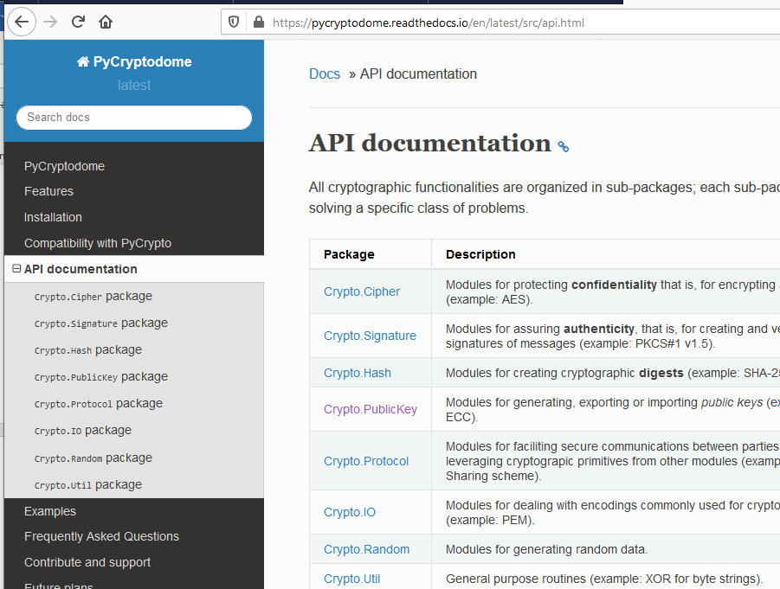

Another place is in the installation directories. The installation is well structured, so the directories correspond to the different packages.  
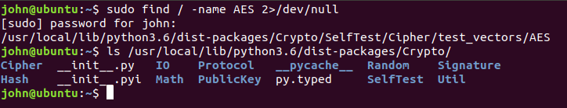

The __init__.py file describes the modules.  
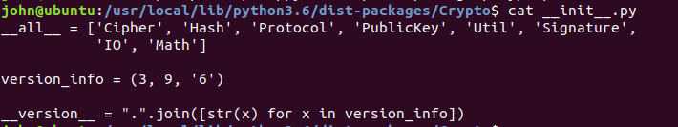

The windows installation really buries these files.  
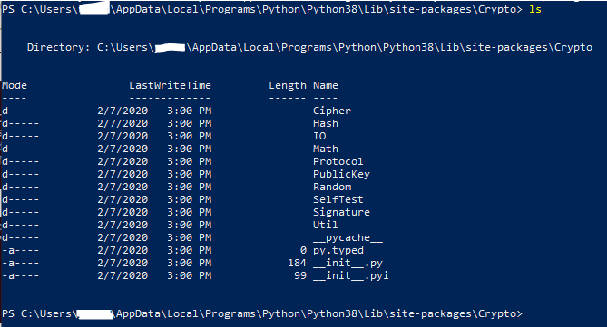

</SIDEBAR>